MODULE 4 – INTRODUCTION TO DBMS

LAB EXERCISES

8. Data Query Language – DQL
Lab 1.
Retrieve all courses from the courses table using the SELECT statement.
Ans.
1. SELECT * FROM courses
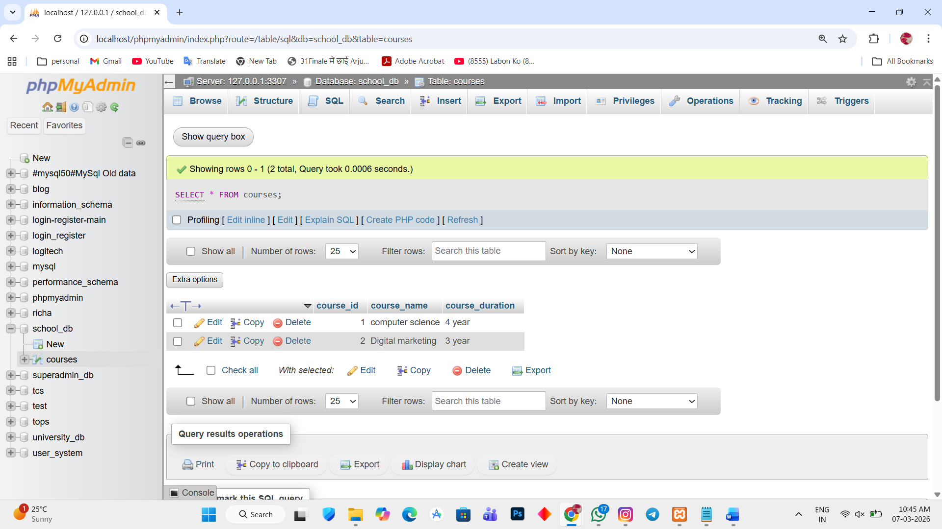

Lab 2.
Sort the courses based on course_durationin descending order using ORDER BY.
Ans.
1. SELECT * FROM courses ORDER BY course_duration DESC;
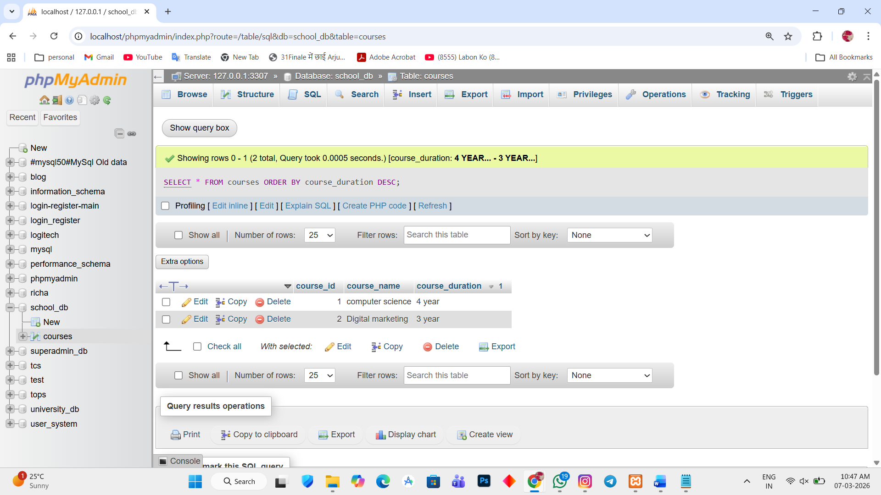

Lab 3.
Limit the results of the SELECT query to show only the top two courses using LIMIT.
Ans.
1. SELECT * FROM `courses` LIMIT 2;
